1.Total number of patients
select count(*) as total_count
from hospital_data;


2.Total number of hospital
select count(distinct hospital_code) as total_hospital
from hospital_data ;


3.Average admission deposit
select avg(Admission_Deposit ) as avg_deposit
from hospital_data ;


4.Average patient visitors
select avg(visitors_with_patient) as avg_visitors
from hospital_data;


5.Patients by admission type
select type_of_admission, count(*) as total_cases
from hospital_data
group by type_of_admission;
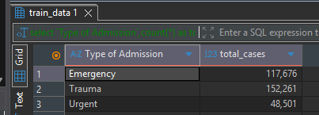

6.Patientsby severity level
select severity_of_illness, count(*) as total_cases
from hospital_data
group by severity_of_illness;
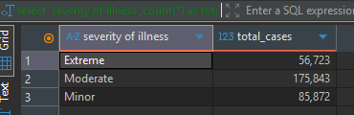

7.Patients by department
select department,count(*)as patient_count
from hospital_data
group by department
order by patient_count desc;
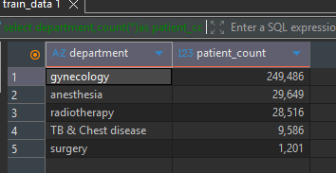

8.Top 10 most cities with most patients
select city_code_patient,count(*) as patient_count
from hospital_data
group by city_code_patient
order by patient_count desc
limit 10;
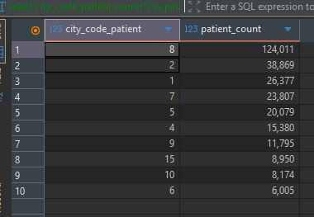

9.Patients by age group
select age,count(*)as total_patients
from hospital_data
group by age
order by total_patients desc;
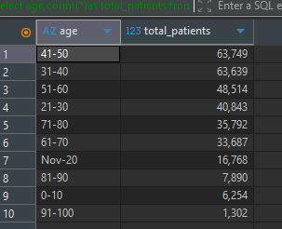

10.Average deposit by severity
select severity_of_illness,
Round(avg(admission_deposit),4) as avg_deposit
from hospital_data
group by severity_of_illness;
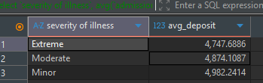

11. Average deposit by department
select department,round(avg(admission_deposit),4)as avg_deposit
from hospital_data
group by department
order by avg_deposit desc;
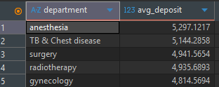

12.Patients by Hospital
select hospital_code,count(*)as total_patients
from hospital_data
group by hospital_code
order by total_patients;
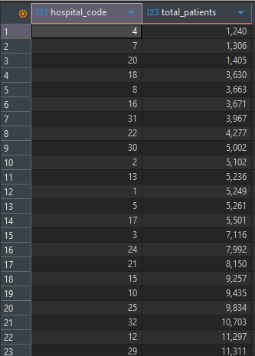


13.Average visitors by severity
select severity_of_illness,avg(visitors_with_patient) as avg_visitors
from hospital_data
group by severity_of_illness ;
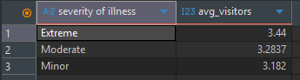

14.Admission deposit by age group
select age,avg(admission_deposit)as avg_deposit
from hospital_data
group by age;
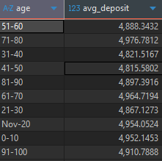

15.Patients by bed grade
select Bed_grade,count(*)as total_patients
from hospital_data
group by Bed_grade;
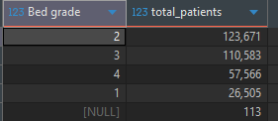

16.Patients with highest deposit
select patientid, admission_deposit
from hospital_data
order by admission_deposit desc
limit 10;
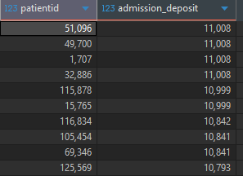

17.Patients with most visitors
select patientid,visitors_with_patient
from hospital_data
order by visitors_with_patient desc
limit 10;
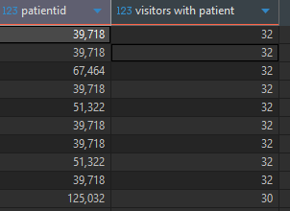

18.Average stay by severity
select severity_of_illness, avg(stay) as avg_stays
from hospital_data
group by severity_of_illness ;
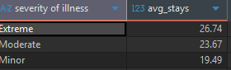

19.Admission type vs average deposit
select type_of_admission,avg(admission_deposit)as avg_deposit
from hospital_data
group by type_of_admission;
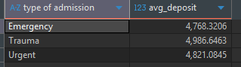

20.Department with highest deposit
select department,Max(admission_deposit)as highest_deposit
from hospital_data
group by department
order by highest_deposit desc;
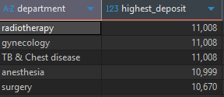

21.Rank hospital by patient count
select hospital_code,
count(*) as patient_code,
Rank() over (order by count(*) desc) as hospital_rank
from hospital_data
group by hospital_code;
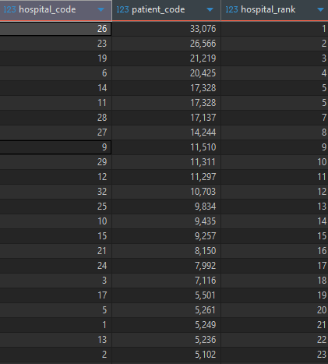

22.Top 5 department with highest patients
select department,count(*)as total_patients
from hospital_data
group by department
order by total_patients desc
limit 5;
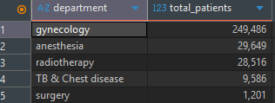

23.Running total of patients by hospital
select hospital_code,
count(*) as patients,
sum(count(*))over(order by hospital_code) as running_total
from hospital_data
group by hospital_code;


24.Rank cities by patient count
select city_code_patient,
count(*)as patient_count,
dense_rank() over (order by count(*) desc)as city_rank
from hospital_data
group by city_code_patient;
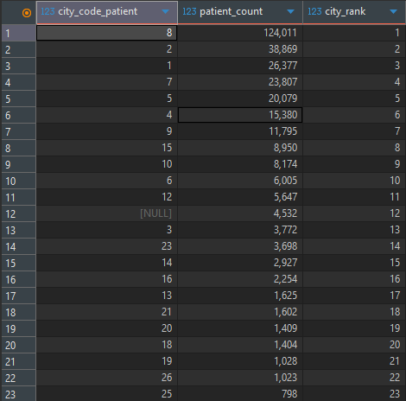

25.Percent% of patients by severity
select severity_of_illness,
round(count(*)*100.0/(select count(*)from hospital_data),2) as percentage
from hospital_data group by severity_of_illness ;
